
Vol 16, Issue 1, (2026) E-ISSN: 2225-8329

The Relationship between Bank Credit and Economic growth: Evidence from Manchester between 2009-2019

Ranjdar Mustafa Ali¹, Nawzad Majeed Hamawandy², Naznaz Nazhat Shaker³, Fria Abdul kareem⁴, Jinan Jamal Fattah⁵, Massooma MIR⁶, Awat Jahfar Abdulmajid⁷, Amer Abdulla Majid⁸, Kawa Ali Khorsheed⁹, Murshed.S.Mohammed¹⁰
¹Department of Business School, University of Wolverhampton, ²Department of Accounting Techniques, Erbil Administration Technical College, Erbil Polytechnic University, Erbil, Iraq, College of Finance and Administration Science, Al-Kitab University, Iraq, ^{3,4,6,7}Technical Department of Accounting, Erbil Technical Administrative College, Erbil Polytechnic University, Kurdistan Region Iraq, ^{5,8}Department of Business Administration, Erbil Administration Technical College, Erbil Polytechnic University, Erbil, Iraq, ⁹Business Administration Department, College of Administration and Economics, Salahaddin University, Erbil, Kurdistan-Region, Iraq, ¹⁰College of Finance and Administration Science, Al-Kitab University, Iraq

DOI Link: http://dx.doi.org/10.6007/IJARAFMS/v16-i1/27285
Published Online: 13 January 2026

Abstract
Economic growth and development is influenced by an increase in bank credit for business organizations, which involves growth in the gross domestic product (GDP). Bank credit plays the role of providing necessary financial resources to enable economic activities. Empirical research reveals a positive relationship between economic growth and bank credit. Meanwhile, other studies have considered the possibility bank credit has not always been sustainable in specific instances, resulting in declining economic growth rate. The study analysis is based on the hypothesis that bank credit plays a significant function in economic growth. The sample period for this study span 2009-2019, and the study was conducted based on data borrowed from the National survey of the Bank of England. Using dynamic generalized method of moments (GMM), this study, concluded that bank credit plays a leading role in providing the necessary financial resources to enable economic growth for Manchester.
Keywords: Bank credit, Economic growth, Manchester, Gross Domestic Product (GDP)

Introduction
Within an economy, banking institutions generally assume an intermediary role of stimulating economic growth through bank credits. Manchester's economic development demands a strong and productive economy in support of various businesses to assist them in moving up the value chain and contributing to economic opportunities. This research will focus on revealing a positive relationship between economic growth and bank credit. Measures of economic growth covers various aspects related to GDP ratio, bank assets, and bank credit. The study will review empirical research on the possibility that bank credit has always influenced economic growth. Some empirical findings consider the relationship between economic growth and bank credit to be either negative or indeterminate. Using dynamic generalized method of moments (GMM), this study will prove the relationship between bank credit and economic growth for Manchester over a period of 2009-2019.

Literature Review
Economic development has always been a benchmark for the successful economic growth of a country. According to Vazakidis & Adamopoulos, (2009), this can be conventionally measured through the increasing rate of Gross domestic product (GDP) value represented in percentage. At the same time, a wide range of policies in the finance and other sectors has been seen to influence the depth and efficiency of finances. The study on the correlation between bank loans and economic development began with J. Schumpeter Mohanty et al. (2016) argued that increasing bank credit or financial growth results in high economic activities. Mateut, Bougheas, & Mizen, (2006) argues that economic development is influenced by the stability of the banking sector and development level, particularly because economic finances generally depend on credit activities.

Caporale et al. (2015) observed the relation between banking sectors and the development of GDP in nearly twenty-five countries through a data panel type of model. The author’s findings revealed that in developing regions, the credits afforded to private companies do not fasten the economy's growth, as causality is unclear in these organizations and the value of credits negatively correlated with the economic growth. Nevertheless, a conclusion reached by Osman (2014) showed that economic growth was encouraged by private credit, which resulted in growth rates of the GDP.

According to a seminal observation by Aydin (2008), a 2.5% decrease in overall credit results in a drop of GDP by nearly 1.5 percent. In a similar observation, Antoshin et al. (2017) showed that economic development could be a fundamental issue for financial growth. This normally takes place when the level of growth in the economy is accountable for enabling the expansion of the financial sectors. Dey & Flaherty (2005) utilized a regression model to observe the way bank credits and stock markets influenced the GDP increase.

Meanwhile, the Cottarelli et al. (2005) considered the possibility that development in credit has not always been sustainable in specific instances, resulting in declining growth rates. Guo & Stepanyan, (2011) in studying financial and growth and economic increase in developing nations used a multivariate approach projected by Durham, (2003) in studying bank crediting and economic development. The models determined the direction between real output and financial sectors.

Messai & Jouini, (2013) examined the macro and micro factors that influence credit expansion and their influence on the overall economy. The findings revealed strong economic conditions with high GDP growth rates and low inflation rates often lead to high credit growth in bank sectors. Pouw and Kakes (2013) observed the economic factors influencing banks' credit increase in twenty-eight countries. The author used the FEM approach and discovered that GDP has a recurring and an optimistic influence on credit increase for financial institutions. The author also discovered an optimistic relationship between long and interim interest rates that negatively influence lending operations. Guo & Stepanyan also examined changes in credit advancement across various emerging market economies and found that inflation has reduced private credit rates.

Bossone, Mahajan, & Zahir, (2003) argues that an economy's infrastructural growth leads to high credit demand, and when the deposit interests are high, the monetary policies are often tightened, and the credit market lessened. From a macro factor perspective, Carlson, Shan, & Warusawitharana, (2013) undertook an observation on the influences of capital to credit development through the Fixed Effects model. When making a deep analysis of credit market works, the property and commercial property markets grow weary with equity ratio, unlike other sectors.

Laidroo & Männasoo, (2014) examined the growth of bank credits for 247 commercial banking systems in eleven countries across Europe from 2004 to 2012. The author concluded that specific factors, such as credit risk and bank size, affect a specific bank's credit growth. During a crisis, the rate of liquidity has a positive correlation with economic development and bank credit. A similar study by Tamirisa & Igan, (2008) conducted among 214 banks in European countries discovered that weak banks keep high growth in their credit fee, and high GDP development and reduced interest rates positively influence credit supply. Thus, well-organized businesses with improved liquidity and profitability promote credit growth.

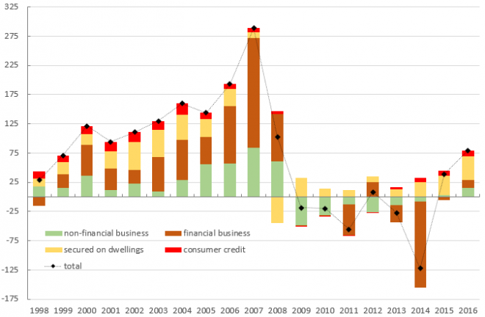
Figure1: Bank credit to business sectors 1998-2016 based on credit figures from Bank of England (Retrieved: https://touchstoneblog.org.uk/2017/02/bank-lending-into-economy-still-very-weak-and-still-dominated-by-property/)

Evidence shows that limited finances have held back several organizations in Manchester despite their need to grow and develop. A current national review of the Bank of England discovered that a third of business organizations argued that they did not adequately invest in the past five years due to limited internal finance, high cost of finance, and insufficient access to finances along with financial market pressures (Hawkins & Klau, 2000). In a recent estimation of credit figures from the Bank of England, Geoff Tilly argued, "banks are lending to purchase houses and not building businesses." According to Tilly's blog, the charts estimate that credits provided for businesses have fallen dramatically after the financial crisis and only began growing again in 2016 (Fig1).

In Manchester, the Selim, Ozdemir, & Dogan, (2013) suggests an obvious issue with accessing bank credits. According to credit data collected for regions from RBS Group, Barclays, Lloyds Banking Group, Santander UK, and Clydesdale & Yorkshire Banks, the author showed that these institutions account for sixty percent of credit banks.

Research Methodology
The term bank credit refers to the amount of credit provided for individuals or business organizations from banking institutions as loans. Economically, bank credit refers to the long, medium, and short-term credits, including credits to businesses and individuals; credits to consumers; housing credits; and credits to non-profit organizations. According to Van den Berg, (2016) economic growth occurs when overall output of newly produced goods and services increase within an economy. The economic growth of a country is measured through gross domestic product (GDP), expected total national income, and average per capita income.

The sample period for this study span 2009-2019, and the study was conducted based on data borrowed from the National survey of the Bank of England. The data for the study includes the dependent variable as the Real GDP growth in reference to economic development and the independent variable as bank credit facilities for all business sectors. As illustrated in Figure 2 below, there is a continuing acceleration of growth in Manchester city sectors. It is estimated that construction will grow at a high rate, as a result of major developments as indicated below. Industries that involve culture, creativity, and digital companies continue making significant contribution to the economy of Manchester.

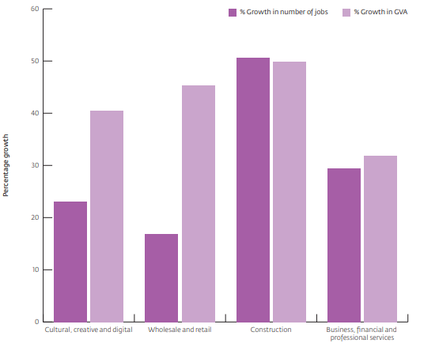
Figure 2: Fastest growing business sectors (Source: Council, 2013)
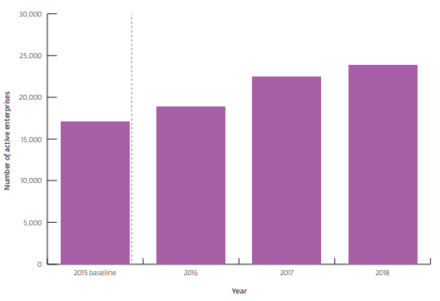
Figure 3: The approximate number of active businesses in a period of five years (Source: Council, 2013)
As depicted in Figure 3, Manchester is also leading in terms of its business enterprise despite uncertainties in national and global economic outlook. The figures represent the various active enterprises that continue to increase annually.

Data and Variables
Using a dynamic generalized method of moments (GMM), this study will prove the relationship between bank credit and economic growth for Manchester over a period of 2009-2019. The GMM approach will focus on endogenous modules through the lag of variables as instruments. GC (2006) used this method to examine the relationship between the stock market and economic development.
The first equation (1.0) illustrates regression equation that determines growth
$$y_{i,t}-yi,t-1=a_{y_{i,t}-1}+ β^{'X_{i,t}}+η_{i}+ε_{i,t}$$

Where $y_{i,t}$ represents real GDP per capita; $β^{'X_{i,t}}$ illustrates the vector of variables with exception of initial level per capita GDP and also involves indicators of financial reforms; $η_{i,t}$ illustrates the specific fixed effects of the country and; $ε_{i,t}$ is the error indicator. The $i$ and $t$ subscripts indicate the country and period.
Bond, Hoeffler & Temple, (2001). argues that differencing the equation (1.0) results to the second equation below (1.1),
$$\left(y_{i,t}-y_{i,t-1}\right)-(y_{i,t-1}-y_{i,t-2}=a\left(y_{i,t}-y_{i,t-1}\right)+β^{'}\left(X_{i,t}-X_{i,t-1}\right)+(ε_{i,t}-ε_{i,t-1})$$

The second equation eliminates any specific effects within a country. To eliminate the bias introduced by new error term and lagged dependent variable, Newey & Smith, (2004) showed the following equation (1.2) to eradicate the bias.
$$E\left[y_{i,t-s}\left(ε_{i,t}-ε_{i,t}-1\right)\right]=0 for s≥2;t=3,…T$$
$$E\left[X_{i,t-s}\left(ε_{i,t}-ε_{i,t}-1\right)\right]=0 for s≥2;t=3,…T$$

Newey & Smith, (2004) believes that the initial difference GMM estimator can mislead the researcher when there is a persistent variable since lagged series level gives weak instrumentation for the subsequent difference. To effectively deal with the issue, Blundell, & Bond (2000) and Bouayad-Agha & Vedrine, (2010) recommended the GMM system. In this case, the equation in (1.2) is used to obtain the system estimators. Achieving consistency of estimators obtained from GMM, it is important to authorize the assumption that the error terms have no serial correlations. For this reason, we can apply the specification tests recommended by Bun, & Windmeijer, (2010). The first one being the Sargan test that considers over-identification restriction and the second one involves checking if the error term $ε_{i,t}$ is not correlated in a serial manner.
Equation (1.3) details the precise speciation of the model.
$PCG_{i,t}= {β_{1}\left({LY}_{0}\right)}_{i,t}+ β_{2}FD_{i,t}+β_{3}FL_{i,t}+β_{4}({FD*FL)}_{i,t}+β_{5}$ Investment$i,t$ + $β_{6}$Trade openness $i,t$ +$β_{7}$ Government Size $i,t$ +$β_{8}$ Inflation$i,t$ + $β_{9}$ Eductaion $i,t$ +$η_{i}+ε_{i,t}$
Where $PCG_{i,t}$= Per capita growth;
${\left({LY}_{0}\right)}_{i,t}$ = GDP per capita initial value;
$FL$ = economic liberalization;
$({FD*FL)}_{i,t}$ = economic growth;
$η_{i}$= specific fixed effects
$ε_{i,t}$= error term

This study hypothesizes that $β_{2}>0$and $β_{4}<0$, which indicates positive economic growth but the overall positive impact is affected by high levels of bank credit reforms. This study focused on estimating economic growth through bank credit. The study suggests the possibility that high bank deposits does not result in increased credit. What indicates economic growth is the actual GDP per capita. The variables were essential in the study and agreement with the observations. The selected model explains the relationship between bank credit and economic development.

Conclusion
Bank credit is an essential connection to financial transmission because it finances production consumption and capital creation, ultimately influencing economic development. In Manchester, financial service sectors make a large regional, regional corporate finance center in England. The long-standing specializations such as industries, transport, high education, and professional services require adaptation of policies and programs to amplify economic development through bank lending. Meanwhile, the relationship between bank credit and economic development has not been adequately analyzed in the context of Manchester. Using dynamic generalized method of moments (GMM), it is evident that bank credit positively influences economic growth in the long-term. Empirical observations show that bank credit plays a leading role in providing the necessary financial resources to enable economic activities.

References
Aydin, B. (2008). Banking structure and credit growth in Central and Eastern European countries. IMF Working Papers, 1-44.
Antoshin, S., Arena, M. M., Gueorguiev, N., Lybek, M. T., Ralyea, M. J., & Yehoue, M. E. B. (2017). Credit growth and economic recovery in Europe after the global financial crisis.
Bossone, B., Mahajan, S., & Zahir, F. (2003). Financial infrastructure, group interests, and capital accumulation: Theory, evidence, and policy. Evidence, and Policy (January 2003). IMF Working Paper, 1-35.
Bouayad-Agha, S., & Vedrine, L. (2010). Estimation strategies for a spatial dynamic panel using GMM. A new approach to the convergence issue of European regions. Spatial Economic Analysis, 5(2), 205-227.
Bun, M. J., & Windmeijer, F. (2010). The weak instrument problem of the system GMM estimator in dynamic panel data models. The Econometrics Journal, 13(1), 95-126.
Blundell, R., & Bond, S. (2000). GMM estimation with persistent panel data: an application to production functions. Econometric reviews, 19(3), 321-340.
Caporale, G. M., Rault, C., Sova, A. D., & Sova, R. (2015). Financial development and economic growth: Evidence from 10 new European Union members. International Journal of Finance & Economics, 20(1), 48-60.
Cottarelli, C., Dell’Ariccia, G., & Vladkova-Hollar, I. (2005). Early birds, late risers, and sleeping beauties: Bank credit growth to the private sector in Central and Eastern Europe and in the Balkans. Journal of banking & Finance, 29(1), 83-104.
Council, M. C. (2013). Manchester’s State of the City report. Retrieved July, 16, 2014.
Carlson, M., Shan, H., & Warusawitharana, M. (2013). Capital ratios and bank lending: A matched bank approach. Journal of Financial Intermediation, 22(4), 663-687.
Dey, M. K., & Flaherty, S. (2005). Stock exchange liquidity, bank credit, and economic growth. In Max Fry Conference on Finance and Development, University of Birmingham, The Business School University House, Birmingham B15 2TT.
Durham, J. B. (2003). Foreign portfolio investment, foreign bank lending, and economic growth. FRB International Finance Discussion Paper, (757).
Demetriades, P. O., & Hussein, K. A. (1996). Does financial development cause economic growth? Time-series evidence from 16 countries. Journal of development Economics, 51(2), 387-411.
Guo, K., & Stepanyan, V. (2011). Determinants of bank credit in emerging market economies. IMF Working Papers, 1-20.
GC, S. B. (2006). Stock market and economic development: a causality test. The Journal of Nepalese Business Studies, 3(1).
Hawkins, J., & Klau, M. (2000). Measuring potential vulnerabilities in emerging market economies.
Laidroo, L., & Männasoo, K. (2014). Perils of excessive credit growth: evidence from 11 new EU member states. Baltic Journal of Economics, 14(1-2), 17-34.
Levine, R., & Zervos, S. J. (1993). What we have learned about policy and growth from cross-country regressions?. The American Economic Review, 83(2), 426-430.
Loayza, N., & Ranciere, R. (2004). Financial development, financial fragility, and growth. The World Bank.
Mohanty, S. K., Lin, H. J., Aljuhani, E. A., & Bardesi, H. J. (2016). Banking efficiency in Gulf Cooperation Council (GCC) countries: A comparative study. Review of Financial Economics, 31, 99-107.
Mateut, S., Bougheas, S., & Mizen, P. (2006). Trade credit, bank lending and monetary policy transmission. European Economic Review, 50(3), 603-629.
Messai, A. S., & Jouini, F. (2013). Micro and macro determinants of non-performing loans. International journal of economics and financial issues, 3(4), 852.
Newey, W. K., & Smith, R. J. (2004). Higher order properties of GMM and generalized empirical likelihood estimators. Econometrica, 72(1), 219-255.
Osman, E. G. A. (2014). The impact of private sector credit on Saudi Arabia Economic Growth (GDP): An Econometrics model using (ARDL) Approach to Cointegration. Am Int J Soc Sci, 3(6), 109-117.
Pouw, L., & Kakes, J. (2013). What drives bank earnings? Evidence for 28 banking sectors. Applied Economics Letters, 20(11), 1062-1066.
Rioja, F., & Valev, N. (2014). Stock markets, banks and the sources of economic growth in low and high income countries. Journal of Economics and finance, 38(2), 302-320.
Selim, Y., Ozdemir, B. K., & Dogan, B. (2013). Financial development and economic growth nexus in emerging European economies: new evidence from asymmetric causality. International Journal of Economics and Financial Issues, 3(3), 710.
Tamirisa, N. T., & Igan, D. O. (2008). Are weak banks leading credit booms? Evidence from emerging Europe. Comparative economic studies, 50(4), 599-619.
Van den Berg, H. (2016). Economic growth and development. World Scientific Publishing Company.
Vazakidis, A., & Adamopoulos, A. (2009). Credit market development and economic growth. American Journal of Economics and Business Administration, 1(1), 34-40.

